A special issue of The Journal of Solid State Electrochemistry dedicated to the 60th birth day of Chandrakant D. Lokhande released
The Springer Publication, Germany published a special issue in its journal entitled, “ Journal of Solid State Electrochemistry”, dedicated to the 60th birth day of Chandrakant D. Lokhande. The issue contains 25 research articles contributed by scientists across the globe.
This issue is attributed to Prof C D Lokhande, who dedicated his entire life to science and effectively shaped the careers of many young minds. With this tribute the scientific community, particularly his students, friends and colleagues recognized his outstanding contribution to the field of semiconductor thin films, to which he has devoted his professional life. Prof Lokhande’s research work has made a profound impact on several areas of thin film technology, ranging from chemical synthesis to their applications in solar cells, gas sensors and supercapacitors. Moreover, he made a great contribution in designing several prototype devices such as supercapacitors and heterojunction based room temperature gas sensors.
Prof Lokhande is the author of more than 560 papers in international journals with “h” index 74 and more than 19800 citations, edited 9 books, filed more than 50 patents, and directed more than 60 Ph. D theses. He has been awarded with prestigious Alexander von Humboldt fellowship, Germany and Brain Pool fellowships, South Korea. He was a visiting professor at Hanyang University and National Chonnam University, South Korea. Presently, prof Lokhande is working as a Research Director and Dean at D Y Patil University, Kolhapur.
This special issue was released at the hands of Prof Devanand Shinde, Vice Chancellor, Shivaji University, Kolhapur during the inaugural function of “International Conference on Nanotechnology Addressing the Convergence of materials Science, Biotechnology and medical Science”, held at Kolhapur India on November 9th, 2017. Both the Guest Editors of Special issue, Prof Rudolf Holze, Germany and Dr Deepak Dubal, Australia were present on this occasion. The function was also attended by Prof J H Kim, South Korea, Prof Peng, Taiwan, and Prof J J Shim, South Korea and Prof P B Behere, Vice Chancellor, D Y Patil University, Kolhapur.

Release of a special issue of The Journal of Solid State Electrochemistry dedicated to the 60th birth day of Chandrakant D. Lokhande
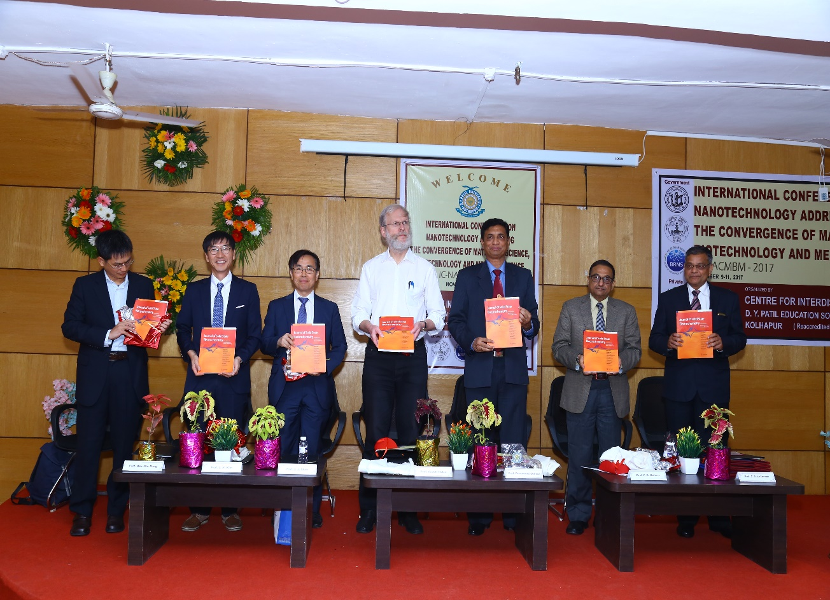
From Right to Left (Prof. Peng, Taiwan, Prof J H Kim, South Korea, Prof J J Shim, South Korea, Prof Rudolf Holze, Germany, Prof Devanand Shinde, Vice Chancellor, Shivaji University, Kolhapur, Prof P B Behere, Vice Chancellor, D Y Patil University, Kolhapur and Prof C D Lokhande)

